Medcin®

Medcin ServerInfo
Installation and User Guide

Last Edited: January 21, 2009

Installation 3
General 3
The ServerInfo Application 4
The Configure button 5
The Save button 6
The Get Info button 6
The Exit button 6

Installation

General
The Setup.exe program in the \Install\ServerInfo will install the ServerInfo application into a Windows-based computer. The installer will place a shortcut in your start programs folder.
If you have installed a previous version of the ServerInfo application, you must remove it using the Add/Remove utility of your operating system.

The ServerInfo Application
The ServerInfo.exe utility program is used to obtain real-time information on the operating of a Medcin server; a 1Q2009 or newer server version is required. When invoked, the application retrieves the information from the currently configured Medcin server. Thereafter, it continues to update the screen at intervals based on the timer value configured. The screen layout of the application appears like the following illustration.
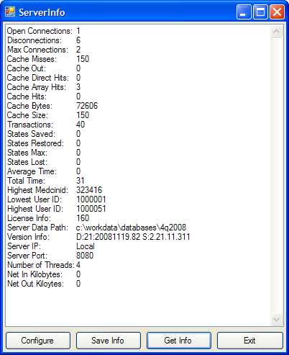
The screen includes a text box that displays the most recent information retrieved from the Medcin server that is currently configured.
The four buttons allow you to:
- Configure the various properties of the application
- Save the last retrieved information to a data file
- Request, on demand, the retrieval of information from the server
- Exit the program
The ServerInfo application only connects to the Medcin server when it needs to retrieve the information.

The Configure button
This button provides access to the configuration dialog so that you can modify the user-configurable properties of the application. The dialog looks like the following image:
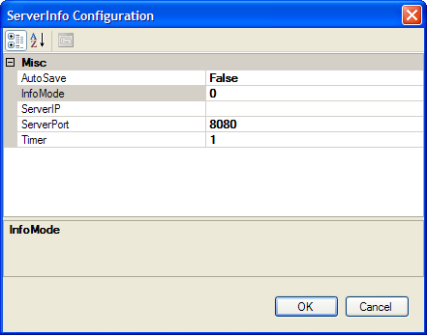
The following properties are configurable:
- AutoSave: This property allows you to turn on or turn off the automatic saving of the information retrieved from the server at timed intervals. The information will be saved to a file in your “My Documents” folder. The filename will be “ServerInfoyyyyMMddhhmm”; the file extension will be either “.txt” or “.xml” based on the InfoMode setting. AutoSave defaults to False.
- InfoMode: This property allows you to specify the format of the retrieved data. A “1” designates XML format; any other value designates plain text format. InfoMode defaults to 0.
- ServerIP: This allows you to specify the IP address of the Medcin server you wish to query. You can enter either the dotted address or the server name (assuming it is resolvable via DNS). ServerIP defaults to an empty string indicating the local machine.
- ServerPort: This allows you to specify the listening port of the Medcin server you wish to query. ServerPort defaults to 8080.
- Timer: This allows you to specify the interval, in minutes, between retrievals of information from the Medcin server. Timer defaults to 1 minute. You will be limited to the largest quantity of milliseconds that can be set on a timer. The shortest interval is one minute.
If you press the OK button, your changes will be immediately used for subsequent requests of information.
If you press the Cancel button, you changes will not be used for subsequent requests of information.
Note that all changes will be saved once you exit the application.

The Save button
This button provides you with the means to save the last information retrieved to a data file on demand. If you have AutoSave enabled, you do not need to use this function. After you press the button, you will be asked to provide the folder and file name to be used to save the data. The default file extension of “.xml” will be provided if the InfoMode is 1; otherwise the file extension provided will be “txt”.

The Get Info button
This button allows you to request the server information on demand. You can use this feature, on demand, if you need a smaller time interval than currently configured.

The Exit button
This button is used to exit the application.

XML format
The following example illustrates the data obtained using InfoMode 1:

<ServerItems>
<ServerItem Name="oc" Value="1" />
<ServerItem Name="dc" Value="4" />
<ServerItem Name="mc" Value="2" />
<ServerItem Name="cm" Value="150" />
<ServerItem Name="co" Value="0" />
<ServerItem Name="cd" Value="0" />
<ServerItem Name="ca" Value="3" />
<ServerItem Name="ch" Value="0" />
<ServerItem Name="cb" Value="72606" />
<ServerItem Name="cs" Value="150" />
<ServerItem Name="nt" Value="28" />
<ServerItem Name="ss" Value="0" />
<ServerItem Name="sr" Value="0" />
<ServerItem Name="sm" Value="0" />
<ServerItem Name="sl" Value="0" />
<ServerItem Name="at" Value="0" />
<ServerItem Name="tt" Value="15" />
<ServerItem Name="mm" Value="323416" />
<ServerItem Name="lu" Value="1000001" />
<ServerItem Name="hu" Value="1000051" />
<ServerItem Name="li" Value="160" />
<ServerItem Name="dp" Value="c:\workdata\databases\4q2008" />
<ServerItem Name="vi" Value="D:21:20081119.82 S:2.21.11.311" />
<ServerItem Name="si" Value="Local" />
<ServerItem Name="sp" Value="8080" />
<ServerItem Name="th" Value="4" />
<ServerItem Name="ni" Value="0" />
<ServerItem Name="no" Value="0" />
</ServerItems>

